**Log Parser Documentation**

**Installation Instructions**

**Prerequisites**

* Node.js (version 14.0 or higher)
* npm (version 6.0 or higher)

**Dependencies**

Core dependencies:

"dependencies": {

    "@ant-design/icons": "^5.5.1",

    "@testing-library/jest-dom": "^5.17.0",

    "@testing-library/react": "^13.4.0",

    "@testing-library/user-event": "^13.5.0",

    "antd": "^5.22.1",

    "axios": "^1.7.7",

    "chart.js": "^4.4.6",

    "file-saver": "^2.0.5",

    "pdfjs-dist": "^4.8.69",

    "react": "^18.3.1",

    "react-chartjs-2": "^5.2.0",

    "react-dom": "^18.3.1",

    "react-pdf": "^9.1.1",

    "react-scripts": "5.0.1",

    "recharts": "^2.13.3",

    "web-vitals": "^2.1.4"

**How to Run**

**Install the dependencies**

npm install

**Development Mode**

1. Start the development server

npm start

1. Open <http://localhost:3000> in your browser

**Production Build**

npm run build

npm run serve

**Screenshots and Features**

**Parser Interface**

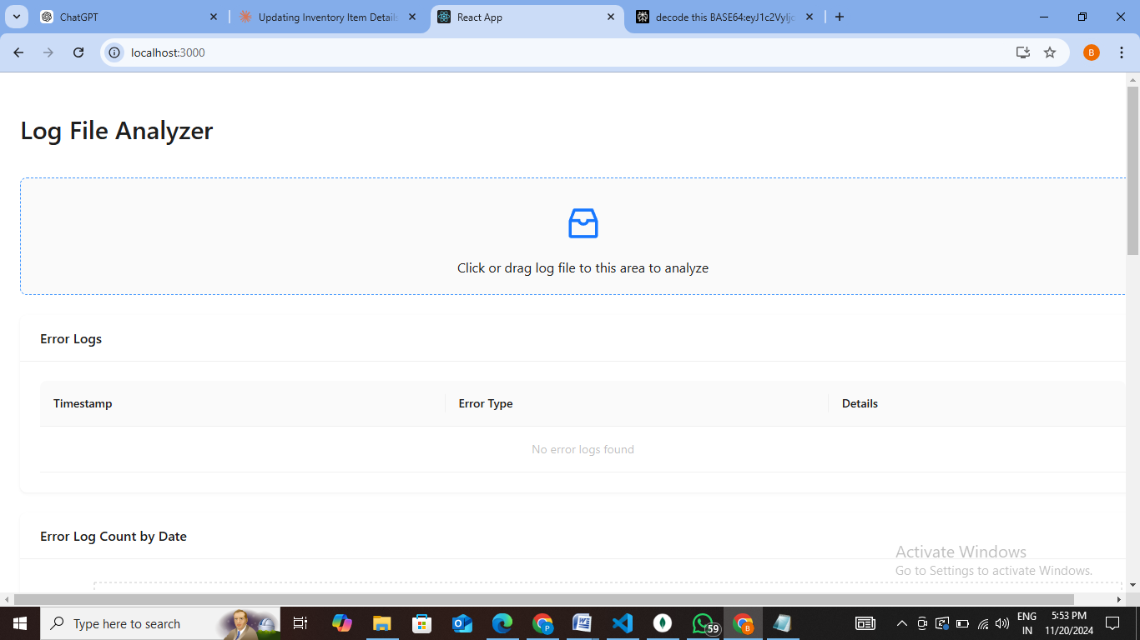

* Upload interface using Ant Design's Upload component

**Data Visualization**

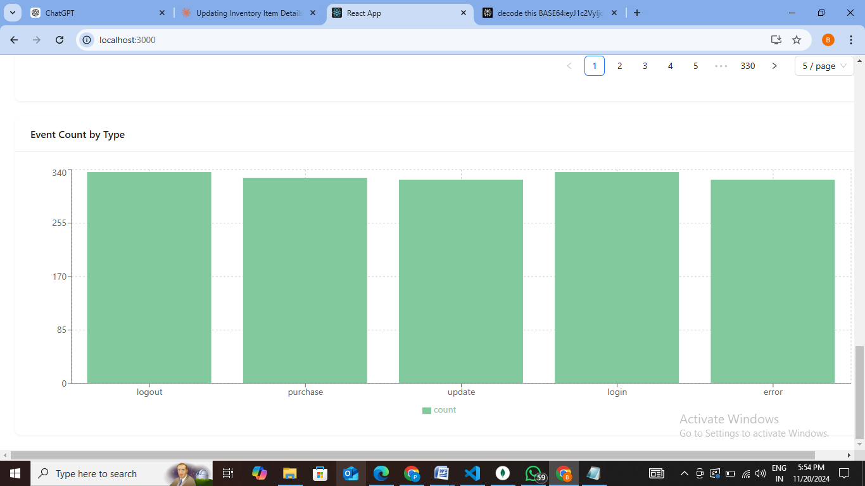

* Interactive charts using Recharts
* Data distribution visualization
* Error rate monitoring

**Results Display**

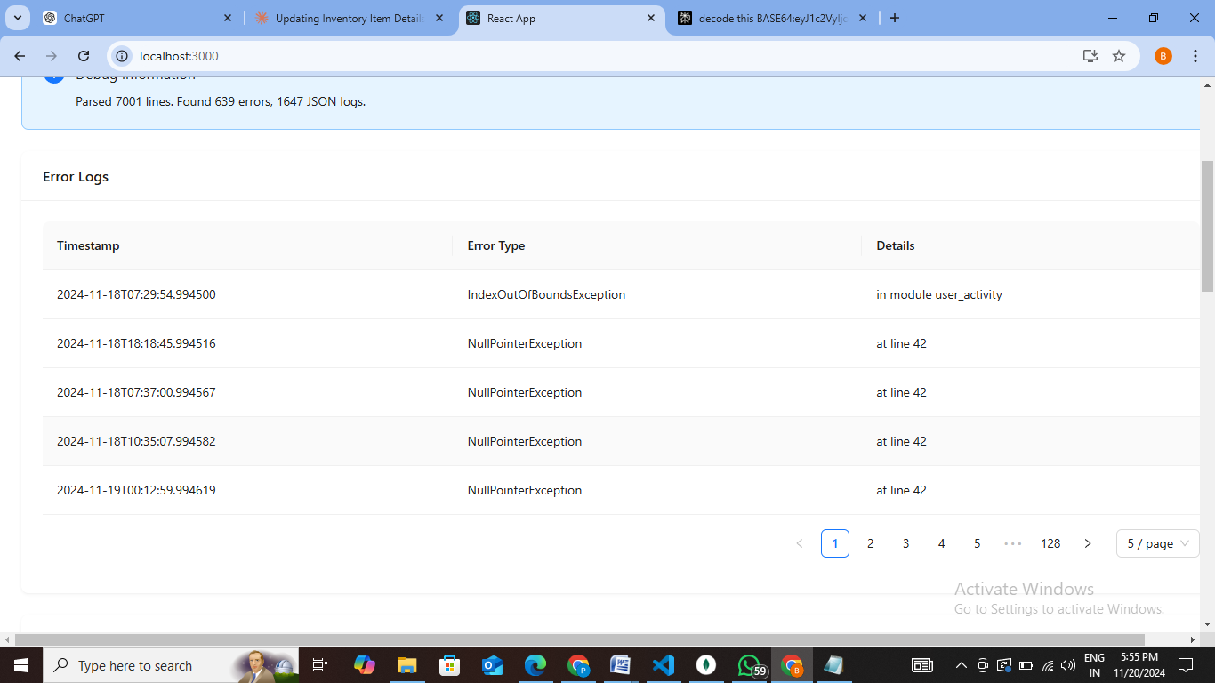

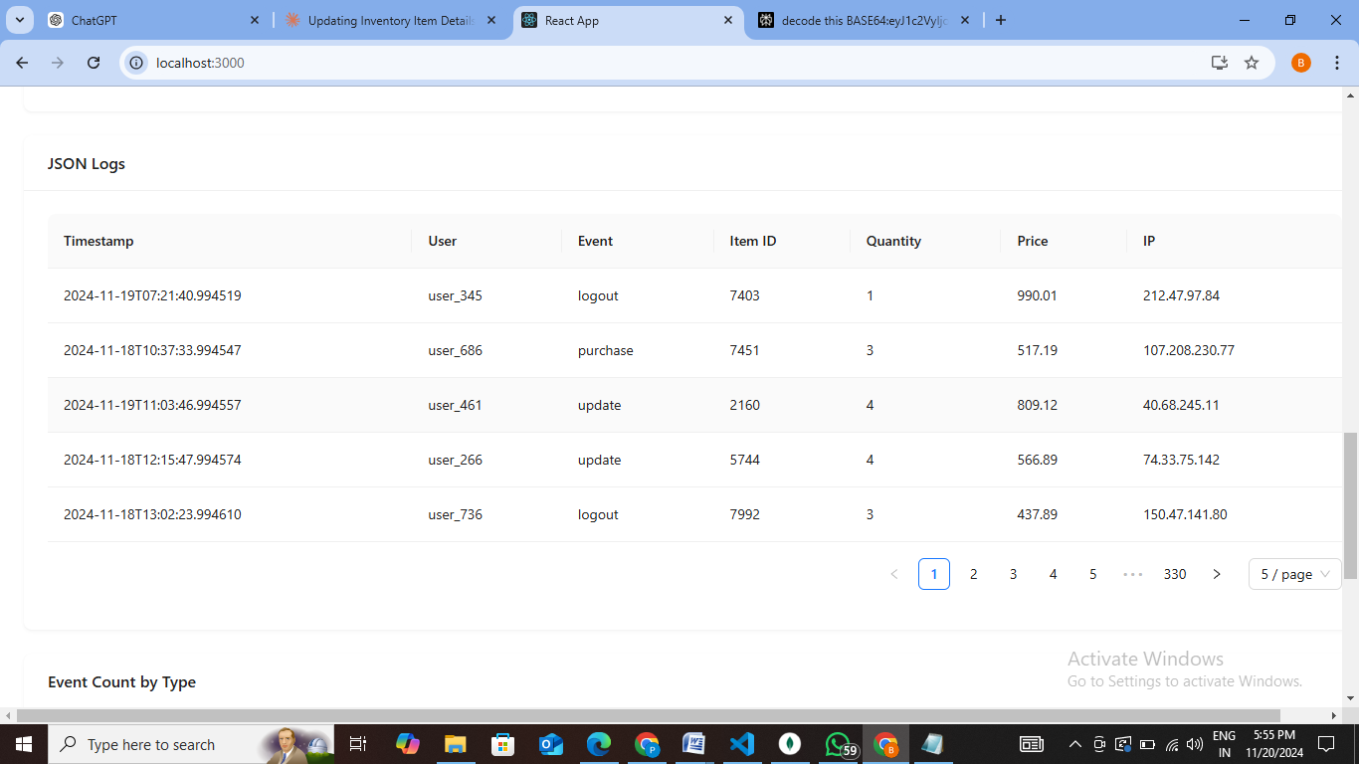

* Sortable table using Ant Design Table component
* Represented the error logs and json logs

The End

* + Bhargavi Peddinti